Animal
Supplementary material
Routine Genomic Evaluation of Mid-Infrared-Predicted Methane Emissions in Holstein Cattle: Validation and Implementation of Methane-Efficiency Breeding
Y. Chen^{a,b,1}, H. Atashi^{a,c,1}, K. Wijnrocxª, H. Bératª, A. Vanlierde^{d}, F. Dehareng^{e}, H. Soyeurtª, A. Gillon^{f}, N. Genglerª
ª TERRA Teaching and Research Center, University of Liège, Gembloux Agro-Bio Tech (ULiège-GxABT), 5030 Gembloux, Belgium
^{b} College of Animal Science and Technology, Hunan Agricultural University, Changsha, China
^{c} Department of Animal Science, Shiraz University, 71441-13131 Shiraz, Iran
^{d} Productions in Agriculture Department, Animal Production Unit, Walloon Agricultural Research Center (CRA-W), 5030 Gembloux, Belgium
^{e} Knowledge and Valorization of Agricultural Products Department, Valorization of Agricultural Products, Biomass and Wood Unit, Walloon Agricultural Research Center (CRA-W), 5030 Gembloux, Belgium
^{f} Elevéo asbl by AWÉ Groupe, 5590 Ciney, Belgium
¹ Y. Chen and H. Atashi contributed equally to this work and shared first authorship.
Corresponding author: Nicolas Gengler. Email: nicolas.gengler@uliege.be

Supplementary Table S1 Regression coefficients used to calculate expected methane emissions for three methane efficiency indices in Walloon Holstein cattle
Index | Explanatory variable (adjusted GEBV) | Coefficient
RMEP | Milk yield | −0.0079
RMEP | Fat yield | 0.2255
RMEP | Protein yield | 0.0733
RMEF | Functional economic index | 0.0214
RMEG | Global economic index | 0.0279

Abbreviations: GEBV = genomic estimated breeding value; RMEP = relative methane efficiency production index; RMEF = relative methane efficiency functional index; RMEG = relative methane efficiency global economic index.

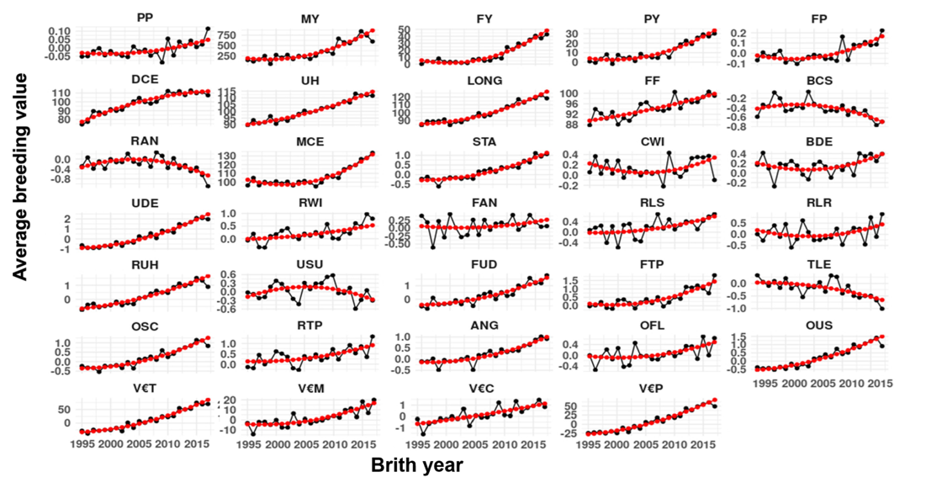
Supplementary Figure S1 Genetic trend and expected mean GEBV for 34 traits and indices of 1 020 selected Holstein bulls. Black and red dots are raw and expected mean GEBV, respectively.
Abbreviations: GEBV = genomic estimated breeding value; MY = milk yield; FY = fat yield; PY = protein yield; FP = fat percentage; PP = protein percentage; UH = udder health; LONG = longevity; FF = female fertility; BCS = body condition score; DCE = direct calving ease; MCE = maternal calving ease; STA = stature; CWI = chest width; BDE = body depth; RAN = rump angle; RWI = rump width; FAN = foot angle; RLS = rear leg set; RLR = rear leg rear view; UDE = udder depth; USU = udder support; FUD = fore udder; FTP = front teat placement; TLE = teat length; RUH = rear udder height; RTP = rear teat placement; ANG = angularity; OFL = overall feet and leg score; OUS = overall udder score; OCS = overall conformation score; V€M = member economic index; V€C = capacity economic index; V€P = udder economic index; V€T = functional type economic index.
Supplementary Table S2 Approximate genetic correlations (AGC) between milk mid-infrared-predicted methane emissions (PCH4) and 37 traits and indices of the breeding goal in Walloon Holstein cattle, based on raw or adjusted GEBV
Trait | AGC with raw PCH4 | SE | AGC with adjusted PCH4 | SE
Milk yield | −0.02 | 0.04 | −0.16 | 0.04
Fat yield | 0.53 | 0.03 | 0.42 | 0.03
Protein yield | 0.25 | 0.03 | 0.10 | 0.04
Fat percentage | 0.55 | 0.03 | 0.52 | 0.03
Protein percentage | 0.42 | 0.03 | 0.39 | 0.03
Udder health | 0.26 | 0.03 | 0.12 | 0.04
Longevity | 0.34 | 0.03 | 0.16 | 0.04
Female fertility | 0.21 | 0.04 | 0.13 | 0.04
Body condition score | 0.10 | 0.04 | 0.15 | 0.04
Direct calving ease | 0.30 | 0.04 | 0.13 | 0.04
Maternal calving ease | 0.13 | 0.04 | −0.04 | 0.04
Stature | 0.03 | 0.04 | −0.13 | 0.04
Chest width | −0.03 | 0.04 | −0.04 | 0.04
Body depth | −0.07 | 0.04 | −0.09 | 0.04
Rump angle | −0.08 | 0.04 | −0.05 | 0.04
Rump width | −0.09 | 0.04 | −0.14 | 0.04
Foot angle | 0.01 | 0.04 | 0.00 | 0.04
Rear leg set | −0.01 | 0.03 | −0.06 | 0.03
Rear leg rear view | 0.07 | 0.04 | 0.05 | 0.04
Udder depth | 0.20 | 0.03 | −0.03 | 0.04
Udder support | −0.12 | 0.04 | −0.12 | 0.04
Fore udder | 0.20 | 0.03 | 0.06 | 0.04
Front teat placement | 0.09 | 0.04 | −0.01 | 0.04
Teat length | −0.03 | 0.03 | 0.02 | 0.04
Rear udder height | 0.11 | 0.04 | −0.10 | 0.04
Rear teat placement | −0.04 | 0.04 | −0.11 | 0.04
Angularity | 0.02 | 0.04 | −0.11 | 0.04
Overall feet and leg score | 0.14 | 0.04 | 0.10 | 0.04
Overall udder score | 0.14 | 0.04 | −0.05 | 0.04
Overall conformation score | 0.08 | 0.04 | −0.09 | 0.04
Production economic index | 0.51 | 0.03 | 0.40 | 0.03
Member economic index | 0.18 | 0.04 | 0.08 | 0.04
Capacity economic index | 0.06 | 0.03 | 0.01 | 0.03
Udder economic index | 0.19 | 0.03 | −0.03 | 0.03
Functional type economic index | 0.22 | 0.03 | 0.02 | 0.04
Functional economic index | 0.35 | 0.03 | 0.17 | 0.04
Global economic index | 0.54 | 0.03 | 0.42 | 0.03

Abbreviations: AGC = approximate genetic correlation; PCH4 = milk mid-infrared-predicted methane emissions; GEBV = genomic estimated breeding value.
Supplementary Table S3 Approximate genetic correlations (AGC) between three methane efficiency indices and 37 traits and indices of the breeding goal in Walloon Holstein cattle, based on adjusted GEBV
Trait | AGC with RMEP | SE | AGC with RMEF | SE | AGC with RMEG | SE
Milk yield | 0.00 | 0.03 | 0.14 | 0.04 | 0.26 | 0.03
Fat yield | 0.00 | 0.04 | −0.43 | 0.03 | −0.14 | 0.04
Protein yield | 0.00 | 0.03 | −0.11 | 0.04 | 0.12 | 0.04
Fat percentage | 0.00 | 0.04 | −0.51 | 0.03 | −0.37 | 0.03
Protein percentage | 0.00 | 0.04 | −0.36 | 0.03 | −0.23 | 0.04
Udder health | −0.11 | 0.04 | 0.00 | 0.04 | 0.05 | 0.04
Longevity | −0.13 | 0.04 | −0.02 | 0.04 | 0.10 | 0.04
Female fertility | −0.12 | 0.04 | −0.02 | 0.04 | −0.06 | 0.04
Body condition score | −0.10 | 0.04 | −0.10 | 0.04 | −0.10 | 0.04
Direct calving ease | −0.02 | 0.04 | −0.05 | 0.04 | 0.07 | 0.04
Maternal calving ease | 0.05 | 0.04 | 0.12 | 0.04 | 0.18 | 0.04
Stature | 0.02 | 0.03 | 0.10 | 0.03 | 0.06 | 0.04
Chest width | −0.01 | 0.04 | 0.01 | 0.04 | −0.02 | 0.04
Body depth | 0.04 | 0.04 | 0.03 | 0.03 | −0.02 | 0.04
Rump angle | 0.03 | 0.04 | 0.07 | 0.04 | 0.07 | 0.04
Rump width | 0.06 | 0.03 | 0.10 | 0.03 | 0.05 | 0.03
Foot angle | −0.02 | 0.04 | −0.02 | 0.04 | −0.01 | 0.04
Rear leg set | 0.03 | 0.04 | 0.06 | 0.03 | 0.00 | 0.03
Rear leg rear view | −0.03 | 0.04 | −0.05 | 0.04 | 0.04 | 0.04
Udder depth | −0.08 | 0.04 | 0.08 | 0.04 | 0.07 | 0.04
Udder support | 0.02 | 0.04 | 0.10 | 0.04 | 0.05 | 0.04
Fore udder | −0.12 | 0.04 | −0.04 | 0.04 | −0.03 | 0.04
Front teat placement | 0.01 | 0.03 | 0.00 | 0.04 | 0.02 | 0.04
Teat length | −0.11 | 0.03 | −0.03 | 0.03 | −0.08 | 0.03
Rear udder height | −0.03 | 0.04 | 0.10 | 0.04 | 0.14 | 0.04
Rear teat placement | 0.08 | 0.03 | 0.09 | 0.04 | 0.06 | 0.04
Angularity | 0.05 | 0.03 | 0.07 | 0.04 | 0.05 | 0.04
Overall feet and leg score | −0.05 | 0.04 | −0.09 | 0.04 | 0.03 | 0.04
Overall udder score | −0.09 | 0.04 | 0.08 | 0.04 | 0.10 | 0.04
Overall conformation score | −0.03 | 0.04 | 0.08 | 0.04 | 0.10 | 0.04
Production economic index | 0.00 | 0.04 | −0.40 | 0.03 | −0.10 | 0.04
Member economic index | −0.05 | 0.04 | −0.07 | 0.04 | 0.04 | 0.04
Capacity economic index | −0.01 | 0.04 | 0.02 | 0.03 | 0.10 | 0.03
Udder economic index | −0.09 | 0.04 | 0.06 | 0.04 | 0.09 | 0.04
Functional type economic index | −0.09 | 0.04 | 0.02 | 0.04 | 0.10 | 0.03
Functional economic index | −0.12 | 0.04 | 0.00 | 0.04 | 0.10 | 0.04
Global economic index | −0.09 | 0.04 | −0.32 | 0.03 | 0.00 | 0.04

Abbreviations: AGC = approximate genetic correlation; GEBV = genomic estimated breeding value; RMEP = relative methane efficiency production index; RMEF = relative methane efficiency functional index; RMEG = relative methane efficiency global economic index.

